SIMATS ENGINEERING
ASSESSMENT TOOL 1

COURSE NAME: INTERNET PROGRAMMING
COURSE CODE: CSA4308
1: Online Symposium Portal
A college is developing an online symposium registration portal. The following HTML
structure and HTTP interaction is observed:
&lt;form action=&quot;/register&quot; method=&quot;POST&quot;&gt;
&lt;input type=&quot;text&quot; name=&quot;name&quot;&gt;
&lt;input type=&quot;email&quot; name=&quot;email&quot;&gt;
&lt;button&gt;Submit&lt;/button&gt;
&lt;/form&gt;
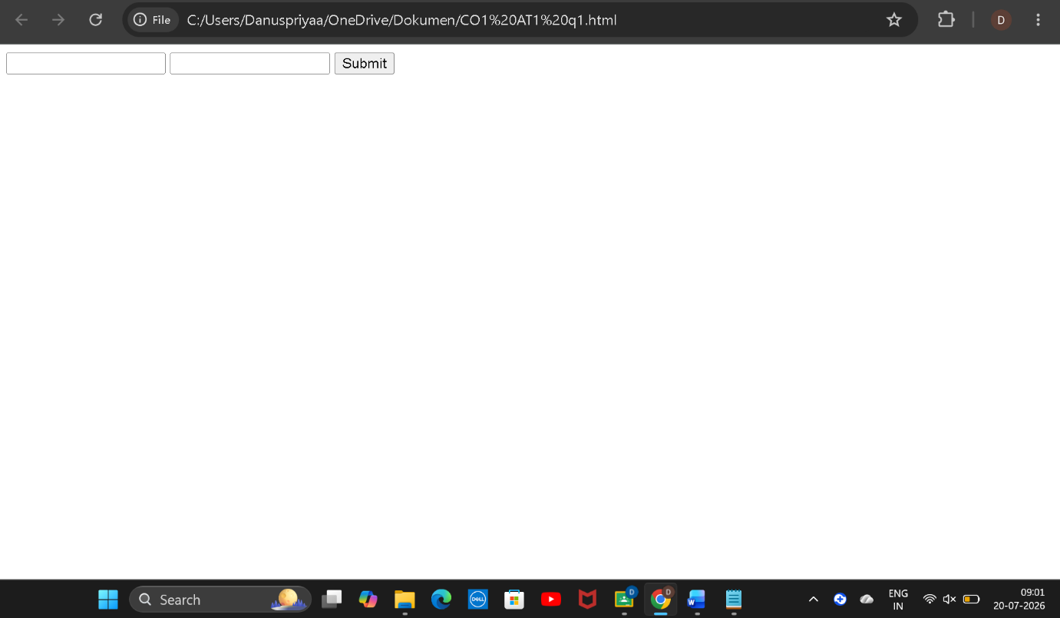
When a student submits the form, the browser sends an HTTP request to the server, and the
server responds accordingly.
Questions:
- Identify appropriate HTML5 semantic elements missing in the structure.
Missing Semantic Element
<header>
<main>
<section>
<label>
<footer>

- Modify the structure to make it standards-compliant.
<!DOCTYPE html>
<html lang="en">
<head>
<meta charset="UTF-8">
<meta name="viewport" content="width=device-width, initial-scale=1.0">
<title>Online Symposium Registration</title>
</head>
<body>

<header>
<h1>Online Symposium Registration Portal</h1>
</header>

<main>
<section>
<h2>Student Registration Form</h2>

<form action="/register" method="POST">

<label for="name">Name:</label>
<input type="text" id="name" name="name" required>

<br><br>

<label for="email">Email:</label>
<input type="email" id="email" name="email" required>

<br><br>

<button type="submit">Submit</button>

</form>
</section>
</main>

<footer>
<p>&copy; 2026 College Symposium</p>
</footer>

</body>
</html>
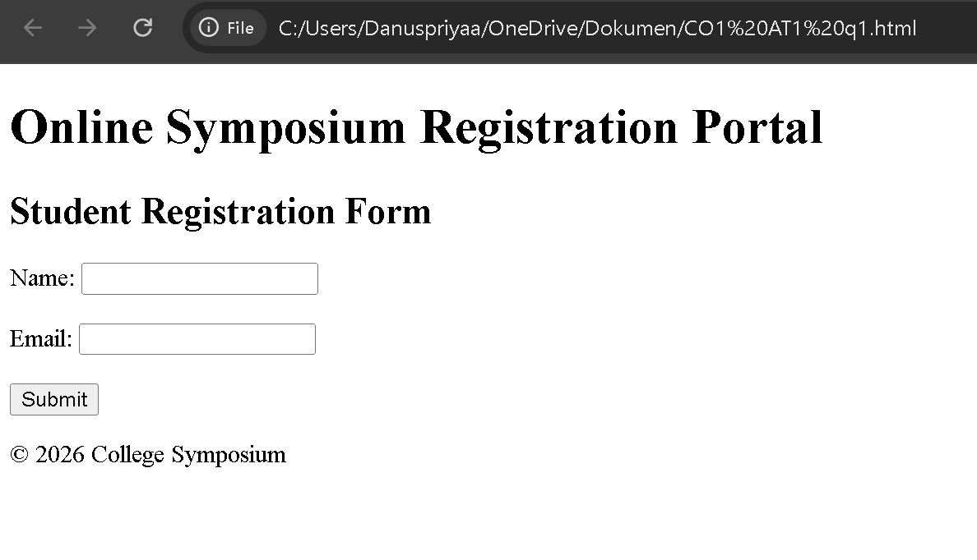

- Interpret the HTTP request generated during form submission.
POST /register HTTP/1.1
Host: www.college.edu
Content-Type: application/x-www-form-urlencoded
name=John+Doe&email=john@example.com

- Analyze the HTTP response cycle from server to browser.
After receiving the HTTP POST request, the server processes the submitted data by validating it and storing it in the database if it is valid. The server then sends an HTTP response back to the browser. If the registration is successful, the server returns a 200 OK status with a success page. If there is an error, it returns an appropriate status code such as 400 Bad Request, 404 Not Found, or 500 Internal Server Error. Finally, the browser displays the server's response to the user.

- Suggest improvements for usability and accessibility.
The usability and accessibility of the symposium registration portal can be improved by using labels for input fields, making fields required, using proper input types such as email, providing placeholder text, displaying clear error and success messages, using HTML5 semantic elements, ensuring keyboard accessibility, maintaining good color contrast, making the page responsive, and using descriptive button text. These improvements make the portal easier to use and more accessible for all users.

2: Cross-Browser Compatibility Issue

A company website shows inconsistent layout across browsers. The following HTML snippet
is used:
&lt;html&gt;
&lt;head&gt;
&lt;title&gt;Company&lt;/title&gt;
&lt;/head&gt;
&lt;body&gt;
&lt;div&gt;
&lt;h1&gt;Welcome
&lt;p&gt;About us
&lt;/div&gt;
&lt;/body&gt;
&lt;/html&gt;
Questions:
- Identify improper nesting and missing closing tags.
Missing closing tag for <h1>.
Missing closing tag for <p>.
Missing <!DOCTYPE html>.
Missing lang attribute in the <html> element.

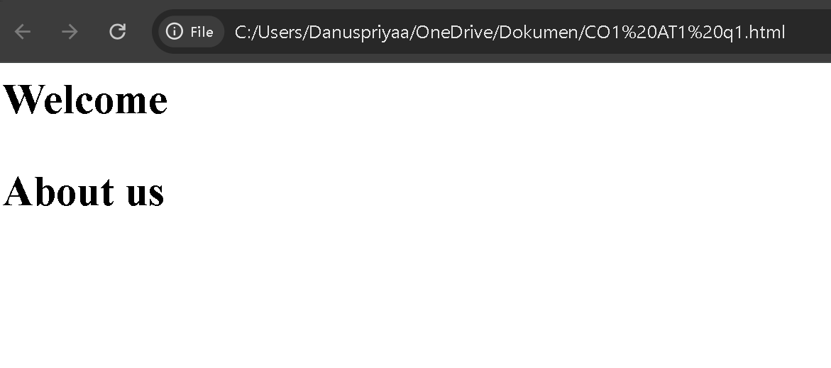

- Analyze how different browsers may interpret this structure.
Different browsers automatically correct invalid HTML in different ways. Because the <h1> and <p> tags are not closed properly, browsers may render the page differently, resulting in inconsistent layout and formatting.

- Identify missing semantic elements (e.g., header, section).
<header>
<main>
<section>
<footer>

- Provide a corrected W3C-compliant HTML structure.
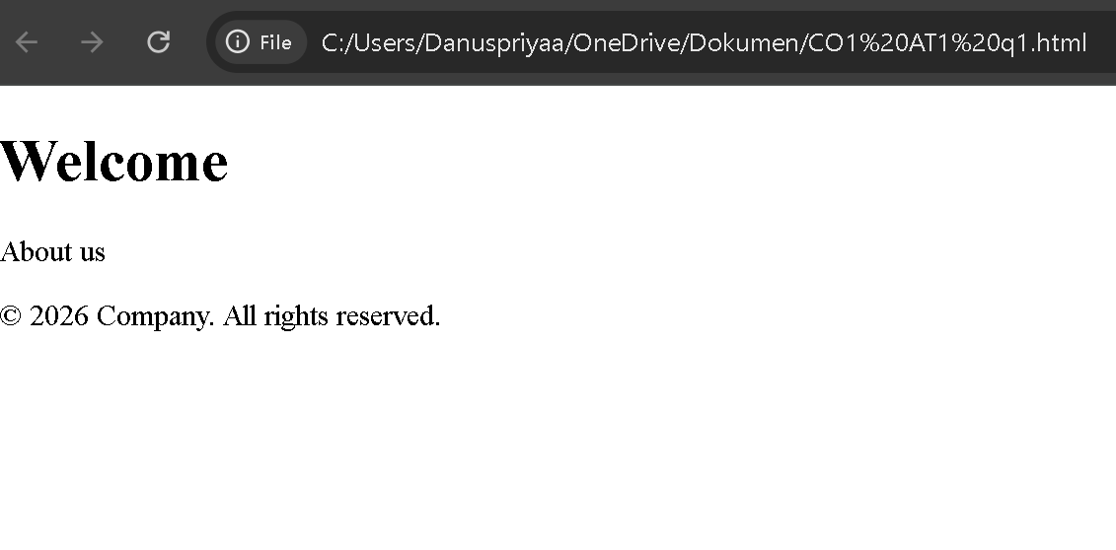

- Suggest techniques to ensure cross-browser compatibility.
To ensure cross-browser compatibility, developers should write valid HTML, close all tags properly, use HTML5 semantic elements, test the website in multiple browsers, use responsive design, follow standard CSS practices, validate the code using W3C validators, and use CSS reset/normalize stylesheets. These techniques help the website display consistently across different browsers.

3: Form Submission Failure
A web application fails to send form data to the server. The following configuration is
observed:
&lt;form action=&quot;/submit&quot; method=&quot;GET&quot;&gt;
&lt;input type=&quot;text&quot; name=&quot;username&quot;&gt;
&lt;input type=&quot;password&quot; name=&quot;password&quot;&gt;
&lt;button type=&quot;button&quot;&gt;Login&lt;/button&gt;
&lt;/form&gt;
Questions:
- Identify issues in the form configuration.
type="button" does not submit the form.
method="GET" is not secure for login credentials.
Missing required attributes.
Missing <label> elements.

- Analyze why the HTTP request is not triggered.
The HTTP request is not triggered because the button is of type button instead of submit. A button does not submit the form unless JavaScript is used. Therefore, no request is sent to the server.

- Interpret the role of GET method in this scenario.
The GET method appends form data to the URL. It is mainly used for retrieving data. Since the username and password become visible in the URL, GET is not suitable for login forms or other sensitive information.
Example: /submit?username=John&password=12345

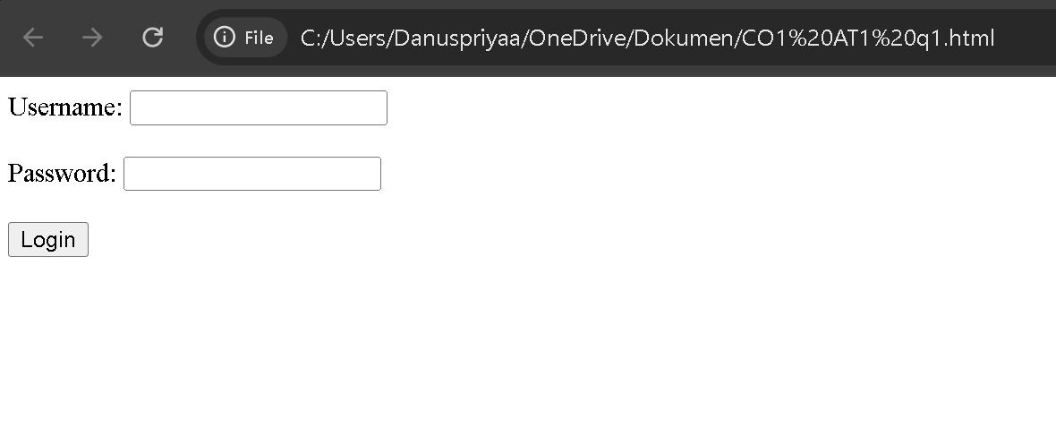
- Propose a corrected implementation.

- Suggest improvements for secure data transmission.
To improve security, use the POST method instead of GET, transmit data over HTTPS, validate user input on both the client and server, use strong password policies, avoid sending passwords in the URL, implement secure session management, use CSRF protection, and store passwords in a hashed format. These measures help protect user credentials and improve the overall security of the web application.

